# S. Y. B. Tech (ECE)

**Trimester: VI Subject: Linux Based Python Laboratory (CET2005A)**

# Name: Class:

**Roll No.: Batch:**

# Experiment – 06 Title: File Handling Concepts of Python

**Marks**

**Teacher’s Signature with date**

**Performed on:**

# Submitted on:

**Aim**: Introduction to File Handling Concepts of Python

**Objective:** Write a python program to perform following file handling operations: Create, Open, Append, Read, Write

File Handling Concepts (Attempt any one)

* Write a python program to perform following file handling operations: Create, open, append, Read, Write
* Write a python program to count occurrences of characters, numbers, newlines, special characters, spaces from a file and write it in a new file
* Create a database of (Bank/library/students) and write it in a file. Perform different operations like read, write, search, update, delete

# Theory:

* A File is an object on a computer that stores data, information, settings, or commands used with a computer
* Advantages of Files
* Data is stored permanently
* Updating data becomes easy
* Data can be shared amongst various programs
* Huge amount of data can be stored

# File Types

|  |  |
| --- | --- |
| **Text Files** | **Binary Files** |
| Stores the data in the form of String | Stores data in the form of bytes |
| Example:  “Hello” is stored as 5 characters | “Hello” is stored as 5 bytes |
| Example:  .txt, .c , .cpp | .jjpg, .gif, .png |

**File Types : Text Files**

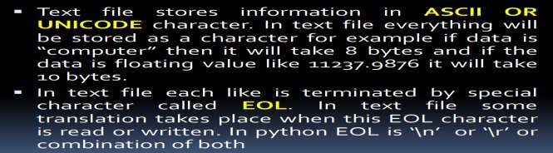

# File Types : Binary Files

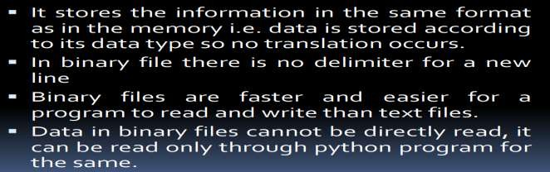

**File Handling**

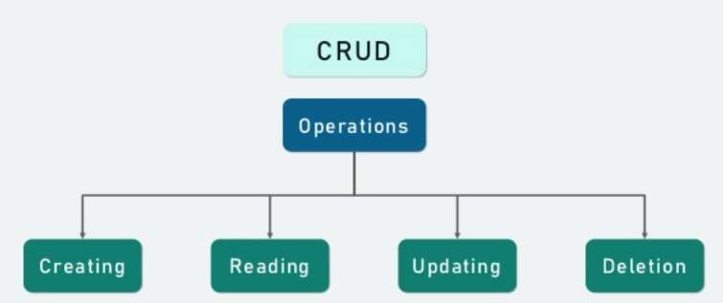

# Opening a File

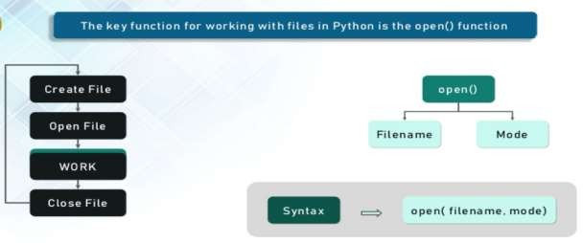

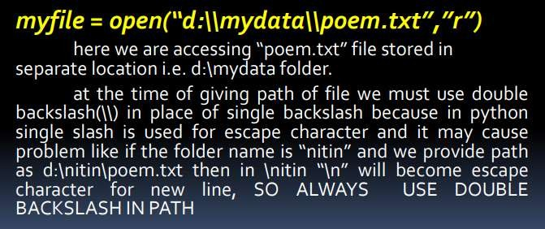

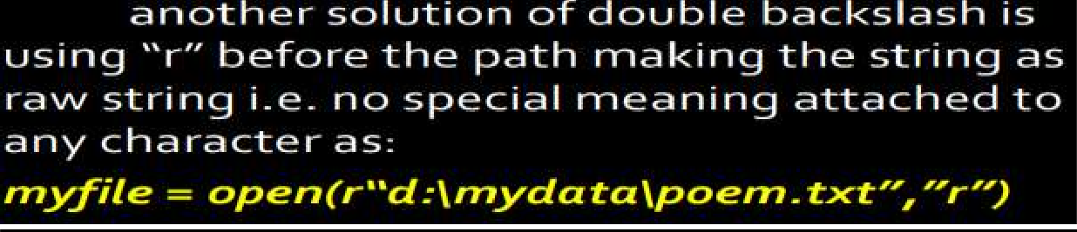

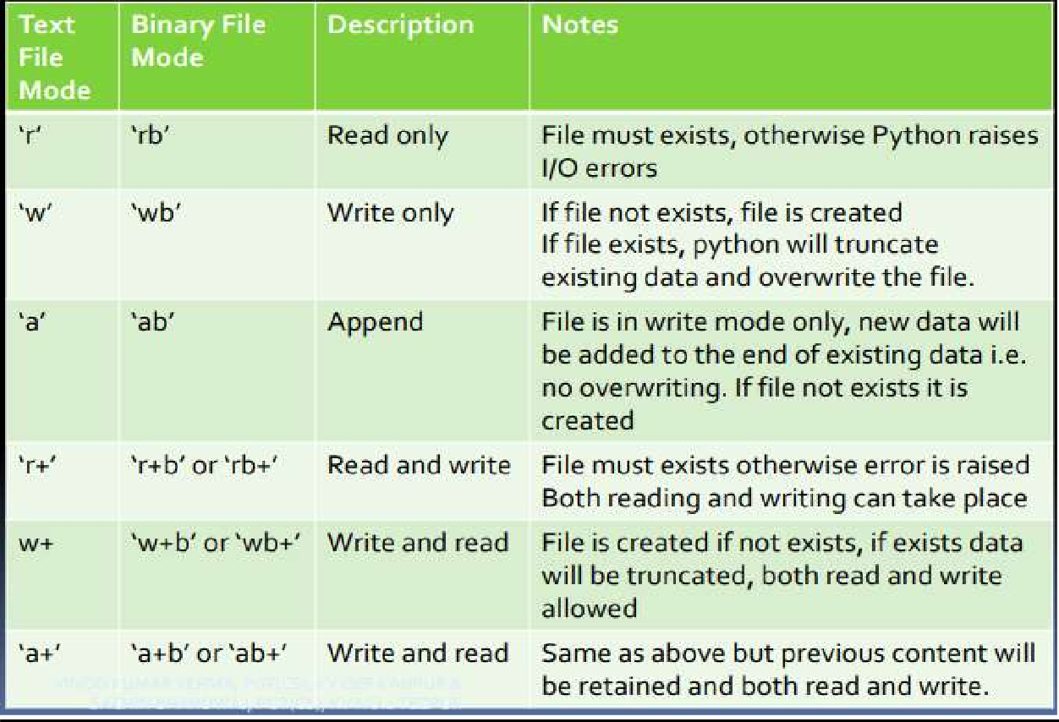

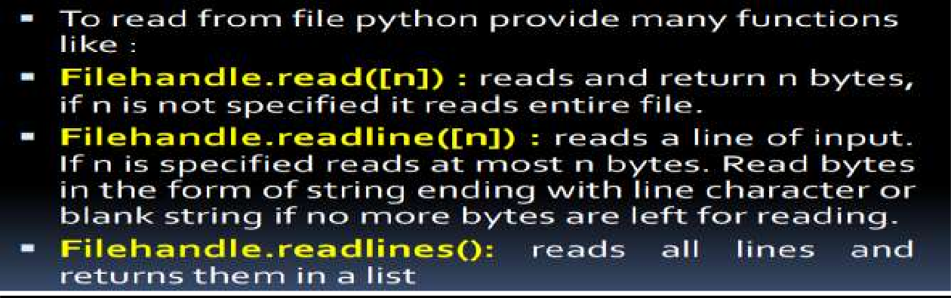**Reading from File**

# Writing onto Files

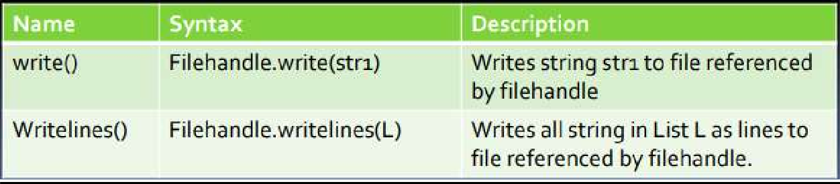

**Copy Content of one file to other**

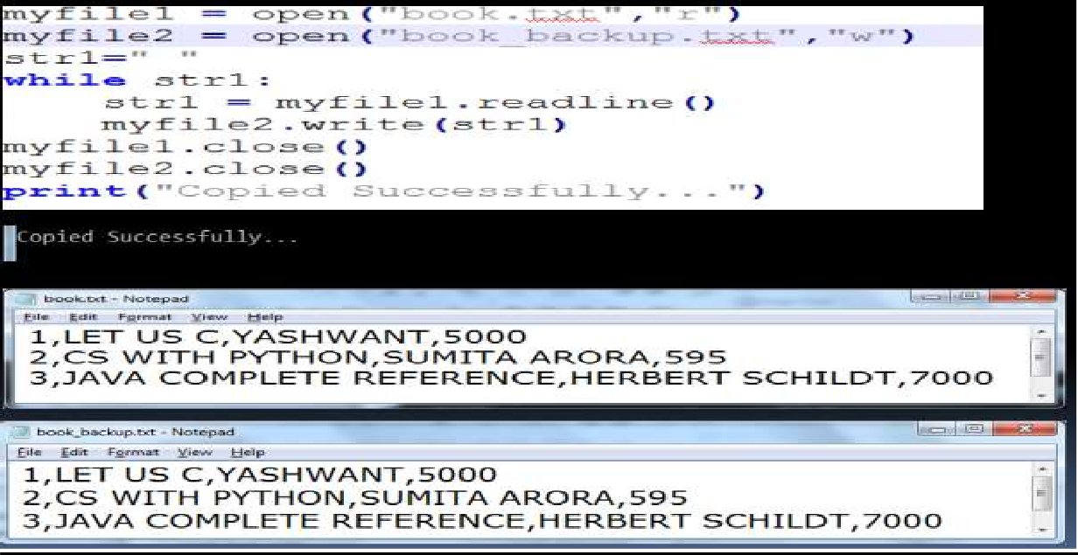

# flush() function

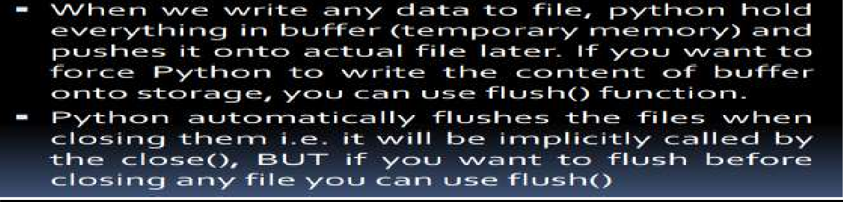

**Files**

# The With Statement

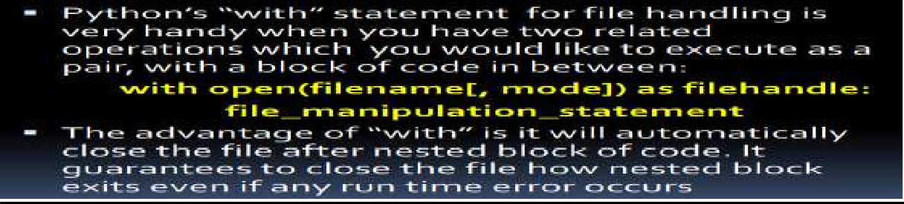

**Binary File Operations**



# Steps to perform binary file operations

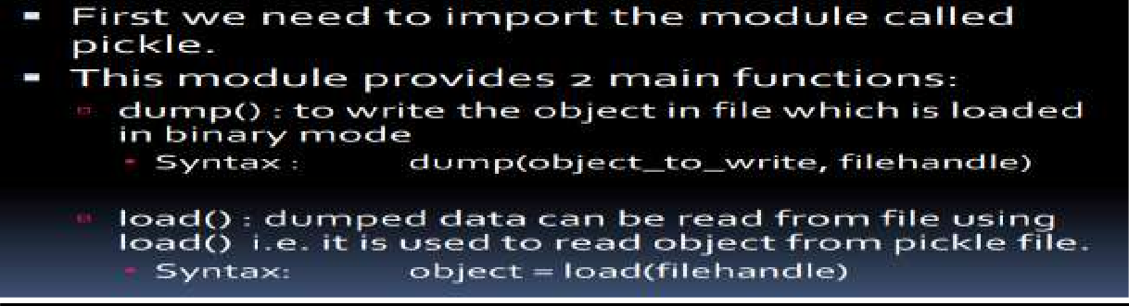

**References:**

**http**[**s://www.w3sc**](http://www.w3schools.com/python/python_file_handling.asp)**h**[**ools.com**](http://www.w3schools.com/python/python_file_handling.asp)**/p**[**ython/python_file_han**](http://www.w3schools.com/python/python_file_handling.asp)**d**[**ling.asp**](http://www.w3schools.com/python/python_file_handling.asp)

**https://stackoverflow.com/questions/39606186/python-class-employee-management-system**

**http**[**s://www.tutor**](http://www.tutorialaicsip.com/cs-xii/file-handling-binary-file-operations-in-python-search-)**ial**[**aicsip.com/cs**](http://www.tutorialaicsip.com/cs-xii/file-handling-binary-file-operations-in-python-search-)**-**[**xii/file-handling-binary-file-operations-in-python-search-**](http://www.tutorialaicsip.com/cs-xii/file-handling-binary-file-operations-in-python-search-) **append-update-and-delete-records/**

**Input:**

# Output:

**Conclusion:**

# Post Lab Questions:

1. Write a function in Python that counts the number of “Me” or “My” (in smaller case also) words present in a text file “STORY.TXT”. If the “STORY.TXT” contents are as follows:

My first book was Me and My Family. It gave me chance to be Known to the world. The output of the function should be: Count of Me/My in file: 4

1. Write a function AMCount() in Python, which should read each character of a text file STORY.TXT, should count and display the occurence of alphabets ‘A’ and ‘M’ (including small cases ‘a’ and ‘m ‘too). Example: If the file content is as follows:

**The AMCount() function should display the output as: A or a = 4, M or m =2**

1. **Write a function in python to count the number of lines in a text file**
2. Write a user-defined function named count() that will read the contents of text file named “Story.txt” and count the number of lines which starts with either “I‟ or “M‟. E.g. In the following paragraph, there are 2 lines starting with “I‟ or “M‟:

“India is the fastest growing economy.

India is looking for more investments around the globe. The whole world is looking at India as a great market.

Most of the Indians can foresee the heights that India is capable of reaching.”